Reflection
Light: Light is a form of energy which causes sensation of sight.
Ray of light: Straight line drawn in the direction of propagation of light is termed as ray of light.
The types of sources of light: The natural source of light is sun. Other manmade (artificial sources) of light are electric bulb, oil lamp, fluorescent tube, sodium lamp, mercury lamp etc. The sources emitting light of their own are called self-luminous. For example the sun, glow worm (i.e., Jugnu) etc. The sources which do not possess their own light but give light called reflected light of other luminous sources are called non-luminous sources, e.g. moon, earth, paper etc.
Speed of light:
Light travels in different speeds in different media.
- Speed of light in vacuum = 3 x 10⁸m/s
- Speed of light in air is almost same as in vacuum, (3x10⁸m/s)
- Speed of light in water = 2.25 x 10⁸m/s
- Speed of light in glass = 1.80 x 10⁸m/s.
Incident ray: It is defined as light traveling in first medium.
Point of incidence: It is a point at which incident ray strikes reflecting surface.
Angle of incidence: The angle which the incident ray makes with the normal at the point of incidence is called angle of incidence. It is represented by ∠i.
Angle of reflection: The angle which the reflected ray makes with the normal at the point of incidence is called angle of reflection. It is represented by ∠r.
Medium of propagation: It may be defined as the path or way through which light passes.
Q) Define reflection of light?
Ans) The phenomenon by virtue of which there is a change in the path of light without any change in the medium. Reflection of light may also be defined as the process of bounding back of light from a reflecting surface in the same medium.
In figure (a) M M¹ is a plane mirror. A ray of light coming from the source “S” falls on the mirror along AO (at an angle ∠AON = ∠i) and is reflected back along OB (at an angle ∠BON = ∠r). In given figure, AO is incident ray, OB is reflected ray, ON is normal to the mirror and O is the point of incidence. ∠i is angle of incidence and ∠r is angle of reflection.
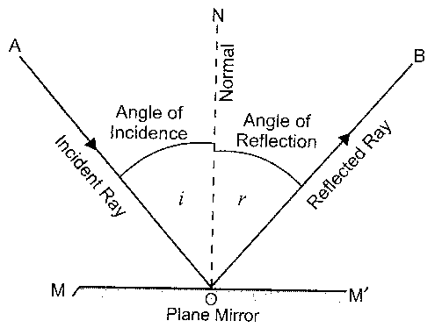

Q) What are the laws of reflection?
Ans) The reflection of light from a plane surface takes place according to the laws which are known as laws of reflection. These laws are stated as follows.
- The angle of incidence is always equal to the angle of reflection, In figure (a)
∠i = ∠r
- The incident ray, the reflected ray and the normal at the point of incidence lie in the same plane. In figure (a) OA, OB and ON all lie in the same plane. These laws are applicable to all types of reflecting surfaces including spherical surfaces.

Q) Define mirror?
Ans) A smooth and well polished surface which reflects regularly most of the light
falling on it is called a mirror.
Mirrors are of two types:- (1) Plane mirror (2) Spherical mirror
- Plane mirror: A highly polished plane (flat) surface, which reflects almost all the light falling on it is known as a plane mirror. In plane mirror opposite sides are always parallel to each other. In a plane mirror, the image of a real object is always (i) virtual (ii) erect (iii) of the same size as the object (iv) laterally inverted
- Spherical mirror: Spherical mirror is a part of hallow sphere with one side highly polished to reflect almost all the light falling on it. Spherical mirrors are of two types: (i) Concave mirror (ii) Convex mirror
- Concave mirror: A concave mirror is that spherical mirror whose outer bulged surface is polished and reflection of light takes place at the concave surface (bent-in surface). The inner shining surface of a spoon is an example of concave mirror.
- Convex mirror: A convex mirror is that spherical mirror whose inner surface is polished and the reflection of light takes place at convex surface (bulged out surface).

Q) Definitions related with spherical mirrors?
Ans) A) Pole: The middle point or centre of the spherical mirror is called pole of the mirror. It is represented by letter “P”.
B) Centre of curvature: It is the centre of hallow sphere of which the mirror is a
part. It is represented by “C”. The centre of curvature of a convex mirror is behind itand that of concave mirror is infront of it.
C) Principal axis: The imaginary line passing through centre of curvature and pole of spherical mirror is called principal axis.
D) Principal focus: The principal focus is a point where a beam of light initially parallel to principal axis appears to converge to a point after reflection or appears to diverge after reflection from the mirror. It is denoted by “F”

Principal focus of a concave mirror: The principal focus of a concave mirror is a point when beam of light initially parallel to the principal axis, actually meet after reflection from the mirror.
Principal focus of a convex mirror: The principal focus of a convex mirror is a point where beam of light initially parallel to the principal axis, appear to diverge after reflection from the mirror.
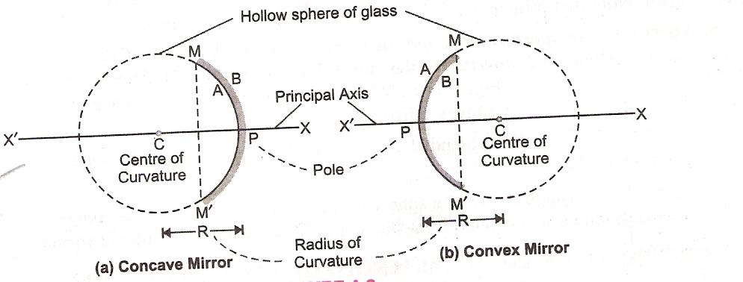

E) Focal length: It is the distance between the pole of the spherical mirror and principal focus. It is represented by “f”.
F) Aperture: It is the effective diameter of reflecting area of the mirror. The aperture
represents the size of the mirror.
G) Radius of curvature: Radius of curvature of a spherical mirror is the radius of the sphere of which mirror is a part. It is represented by the letter “R”.
H) Principal section: A section of a spherical mirror cut by a plane passing through the pole and centre of curvature of the mirror is called principal section of the mirror.
Relation between radius of curvature and focal length:
The focal length of a spherical mirror is equal to half the radius of curvature of the mirror.
i.e. f = ½ R or R = 2f
where R= radius of curvature and f= focal length.
This formula is valid for both concave and convex mirrors.

Q) What rules are used for obtaining images formed by concave mirror?
Ans) When an object is placed in front of a concave mirror, an image is formed at a point where at least two reflected rays intersect. So, identifying the rays of light used to locate the image formed by concave mirror are called rules for obtaining images in concave mirror. The general rules for obtain the image are summarized as follows:
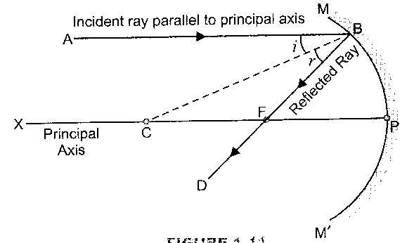
Rule1) The ray of light which is parallel to principal axis of a concave mirror, passes through its focus after reflection from the mirror.

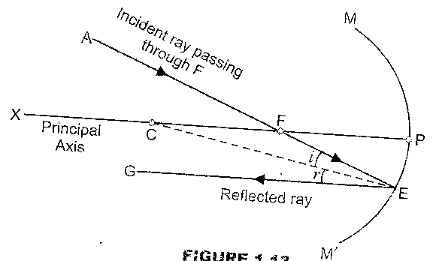
Rule2) A ray of light passing through the focus of a concave mirror becomes parallel to the principal axis after reflection.

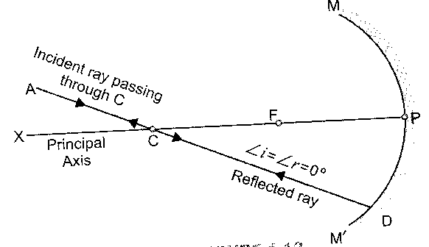
Rule3) A ray of light passing through centre of curvature of a concave mirror is reflected back along the same path.

Rule4) If incident ray strikes the pole making some angle with the principal axis, then the reflected ray also makes the same angle with the principal axis.
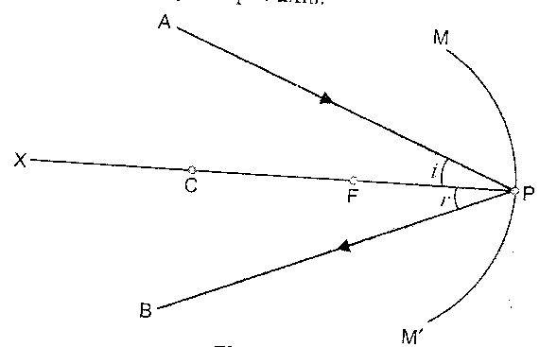

Sign convention used in spherical mirrors.
The new Cartesian sign conventions used for

measuring various distances in the ray diagrams of the spherical mirrors (convex or concave) are summarized as follows:-
- All distances are measured from the pole of the spherical mirror as origin.
- The distances measured in the direction of incident ray are taken as positive while those measured in the direction opposite to the incident light are taken as negative.
- Height of object or image measured in upward direction and perpendicular to the principal axis is taken as positive.
- Heights of object/image measured in downward direction and perpendicular to the principal axis are taken as negative.
- Distance in real image is negative while in virtual image it is positive.
- The principal axis of the mirror is taken along x-axis.

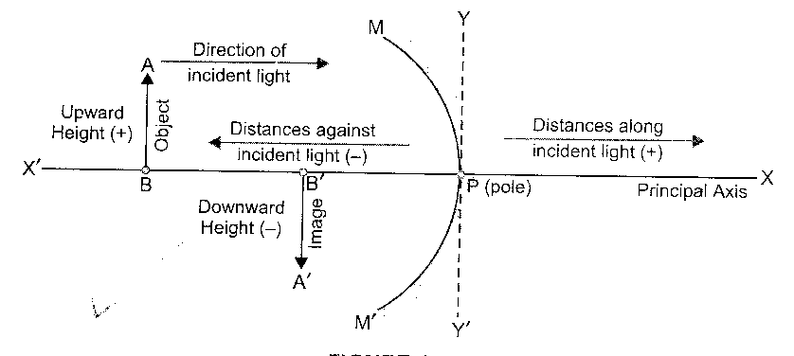
- The object is taken on the left hand side of the mirror.

Q) Define the following terms?
Ans) (a) Object: Any thing which gives us light rays (either its own or reflected by it) is called an object. A bulb, a candle, a pin head, an arrow etc, are examples of objects from the point of view of study of light.
(b) Image: An image is formed when two or more rays coming from an object meet at point after reflection from mirror.
(c) Real Image: A real image is formed when the light rays coming from an object actually meet at a point after reflection from a mirror. Real image is formed in a concave mirror. They can be obtained on a screen (or photographic plate).
(d) Virtual image: It is formed when the light rays coming from an object only appear to meet at a point after reflection from a mirror. These images can not be obtained on a screen. Plane mirrors and convex mirrors always form the virtual images.
Mirror Formula: Relationship between the distance of object “u” from the pole of mirror distance of image “v” from the pole of the mirror and focal length “f” of the mirror is called mirror formula. The mirror formula is written as:
1 ₌ 1 ₊ 1 we know R=2f ---------- 1 ₊ 1 ₌ 1 ₌ 2
f v u u v f R
This formula is valid for all spherical mirrors. New Cartesian sign conventions must be used while substituting numerical values for u,v and f . Mirror formula helps us to find out the position, size and nature of the image formed by spherical mirror. As the object is infront of a mirror i.e. (to the left side) of pole therefore object distance is always negative.
i.e. u = – ve
as the image is formed at the back of mirror i.e. to the right side of pole. Therefore, image distance is always positive.
i.e. v = +ve
Focal length of the convex mirror is always positive. i.e. f = +ve
Focal length of the concave mirror is always negative. i.e. f = – ve
Q) Define linear magnification?
Ans) The linear magnification produced by a concave mirror is defined as the ratio of height of the image (h₁) to the height of the object (h₂). It is represented by “m”.
Linear magnification = height of image (h2)
height of object (h1)
or m = ^{h2}/_{h1}
linear magnification of a spherical mirror is also defined as the ratio of the image distance to the object distance from the pole of the mirror.
m = ^{v}/_{u} = ^{h2}/_{h1}
linear magnification has no units.
1) When size of the image is greater than the size of object.
then h₂ > h₁
as m = ^{h2}/_{h1}, then m>1
The linear magnification is greater than 1 (magnification is very high).
2) When the image is of the same size as that of object then;
h2 = h1
as m = ^{h2}/_{h1} , then m = 1
Thus the magnification is equal to 1
3) When the image is smaller than object i.e.
h2<h1
as m = ^{h2}/_{h1} then m<1
i.e, linear magnification is less than 1 (magnification is very small)
When the image is real and inverted i.e. image lies below the principal axis. Therefore, height (h₂) of the image is negative. As height of an object (h₁) always positive.
Therefore m = ^{-h2}/_{h1} = -ve
Thus when linear magnification is negative the image formed by a concave mirror must be real and inverted and vice versa.
When the image is virtual and erect i.e. Image lies above the principal axis, therefore height (h₂) of the image is +ve. As height of the object (h₁) is always +ve.
Therefore, m = ^{h2}/_{h1} = +ve
Thus when linear magnification is positive, the image formed by a concave mirror is virtual and erect and vice versa.
Q) Discuss the image formation in case of a concave mirror with the help of ray diagram?
Ans) The type of image formed by a concave mirror depends upon the position of the object infront of the mirror. The following six cases arise.
- Case1) When the object is at infinity: When an object is at very large distance from a concave mirror, it is said to be at infinity. Two rays of light AD and E`E coming parallel to the principal axis, get reflected along DF¹ and EF¹. The image is formed at the focus (F). The image is real, inverted and highly diminished.
From infinity
A D
i
E` r E

C F P

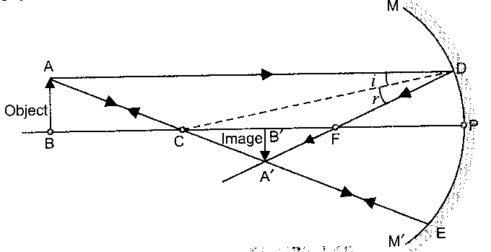
- Case2) When the object is placed beyond the centre of curvature: A ray of light AD coming parallel to the principal axis gets reflected along DF. Another ray of light AE passing through centre of curvature is reflected along EC. (this ray retraces its path) The image is formed between centre of curvature (C) and focus (F). The image is real, inverted and diminished.

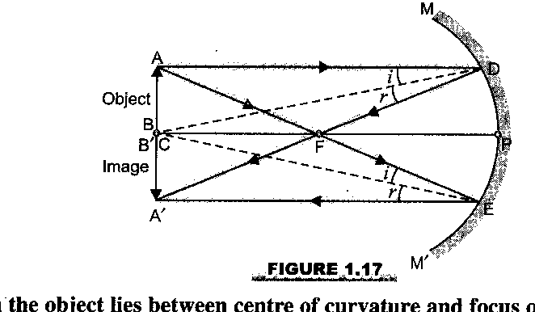
- Case3) When the object is placed at centre of curvature: A ray of light AD parallel to the principal axis is reflected along DA¹. Another ray of light AE passing through the focus is reflected along EA¹ parallel to the principal axis. The image is formed at centre of curvature (C) and is real, inverted and of the same size as that of the object.

- Case4) Object between focus and centre of curvature: When the object AB is placed between (F) and (C). A ray of light AD parallel to principal axis passes through focus (F) after reflection at D. Another ray of light AE passes through centre of curvature (C) after reflection at E (it retraces its path ). The two rays actually meet at A¹. Thus forming the image A¹B¹. It is real, inverted and magnified image and is formed beyond the centre of curvature.

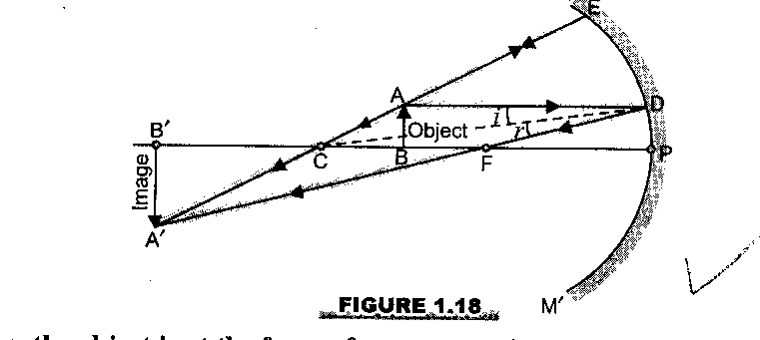

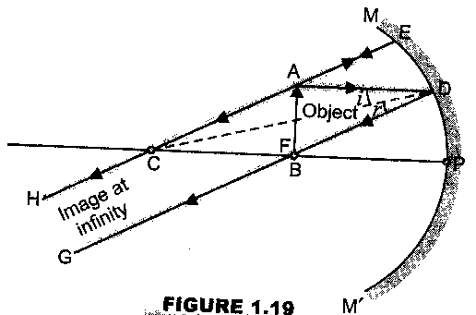
- Case5) Object placed at focus (F): If the object is placed at F focus, all the rays starting from the object become (||) parallel to the principal axis after reflection from mirror and therefore meet at infinity. Thus image formed is at infinity. The image formed is real, inverted and magnified, this image can’t be obtained on screen.

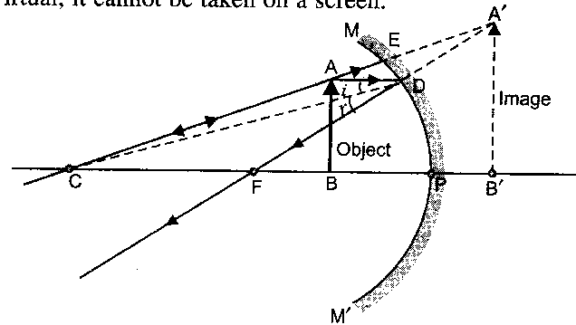
- Case6) Object between pole and focus: A ray of light AD parallel to principal axis passes through focus (F), after reflection at D. Another ray of light AE passes through centre of curvature C after reflection at E (this ray retraces its path). The two reflected rays DF and EAC diverge and cannot meet actually. However, when these two reflected rays are produced back, they appear to come from a common point A¹ behind the mirror. Thus A¹B¹ is the image of the object, which is virtual, erect, magnified and lies behind the mirror. As the image is virtual, it cannot be taken on screen.

Q) Describe the rules for tracing images formed by convex mirror?
Ans) Following are the rules for tracing images formed by convex mirrors.
Rule1) A ray of light falling on the mirror in a direction parallel to the principal axis of a convex mirror appears to be coming from its focus on reflection from the mirror as shown in figure.

Incident rays convex mirror

Principal axis

F C
Focus

Rule2) A ray of light passing through centre of curvature of a convex mirror is reflected back along the same path i.e. such a ray of light retraces its path on reflection as shown in figure.

Incident

Reflected

Principal axis

P C

Rule3) A ray of light passing through focus of a convex mirror becomes parallel to the principal axis of mirror on reflection. This rule is just the reverse of Rule1.

Reflected rays M₁

Principal axis

P F
M₂ Focus
Convex mirror

Rule4) A ray of light incident obliquely towards the pole P of a convex mirror is reflected obliquely. Such that the incident ray and the reflected ray make equal angles with the principal axis.

Incident rays convex mirror
i

Principal axis r P F C

F C
Reflected ray Focus

Q) Discuss the image formation by a convex mirror with the help of a ray diagram?
Ans) The image formed by a convex mirror is always behind the mirror. The image formed is virtual , erect and smaller in size, whenever the distance of the object is changed from convex mirror, then only the position and the size of the image changes. There are two main positions of object in case of a convex mirror from the point of view of position and size of image:
    - At infinity
    - Anywhere between pole (P) and infinity.
- When the object is placed at infinity: A ray of light AP inclined to the principal axis is reflected at P along PG. Another ray of light AD is reflected at D, along DE. The two reflected rays PG and DE, when produced back intersects at point A¹. Thus A¹ B¹ image is formed at focus (f) behind the mirror, the image formed is virtual, erect and highly diminished in size.
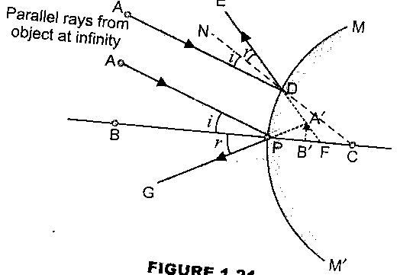

Fig. A

- When the object is placed between infinity and the pole of the mirror: A ray of light AD parallel to principal axis is reflected at D, along DE. Another ray of light AG retraces its pass on reflection at G. the two reflected rays DE and GA when produced back intersect at A. Thus A¹B¹ is the image formed, which is virtual, erect, and diminished in size and lies behind the mirror between P and F.
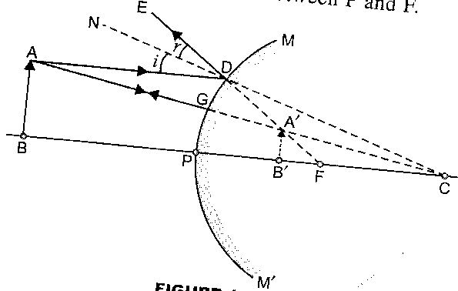

Fig B

Q) What are the uses of spherical mirrors?
Ans) (A) Uses of concave mirrors: (i) They are used as a reflector in torches, search lights, headlights of motor vehicles etc. to get powerful parallel beams of light.
(ii) Concave mirror is used as a shaving mirror as it can form erect and magnified image of the face.
(iii) They are used by doctors to concentrate light on body parts like teeth, ears and eyes, which are to be examined.
(iv) Large concave mirrors are used to concentrate sunlight to produce heat in solar cookers, solar furnaces etc.
(v) Concave mirrors of large diameters are used as objectives in reflecting telescope.
(B) Uses of convex mirrors: (i) A convex mirror is used as a reflector in street lamps. As a result, light from the lamp diverges over a large area.
(ii) A convex mirror is used by drivers of automobiles like cars, buses and trucks as a rear view mirror.
Refraction
Optically rearer medium: A medium is which speed of light is more, is known as optically rearer medium. Air is optically rearer medium as compared to glass and water. Water is optically rearer as compared to glass.
Optically denser medium: A medium in which speed of light is less, is known as optically denser medium. Glass is optically denser than air and water. Water is optically denser than air.
Refraction: The phenomenon of change in the direction of propagation of light when it goes from one medium to another is called refraction. In other words refraction is the phenomenon in which bending of light takes place when it passes from one medium to another medium. The refraction takes place at the boundary of two media. The basic cause of refraction is change in the velocity of light in going from one medium to another medium.
In given figure the incident ray traveling in air medium along “AO” bends and goes along “OB” when it enters glass medium at point “O”.
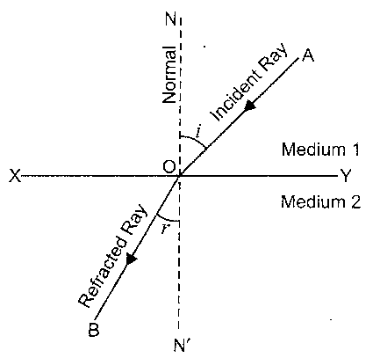
In the given figure “AO” is incident ray, “OB” is refracted ray, ∠BON is angle of refraction and ∠OAN is angle of incidence.

It has been found that when a ray of light goes from an optically denser medium to an optically rearer medium it bends away from the normal and when it goes from a optically rearer medium to an optically denser medium it bends towards normal at the point of incidence.

Laws of refraction:
- It states that the incident ray, the refracted ray and the normal at the point of incidence, all lie in the same plane. In given figure, the incident ray “AO” the refracted ray “OB” and the normal “ON” all lie in the same plane. i.e. plane of paper
- This law gives the relationship between the angle of incidence and angle of refraction. The law was given by Snell in 1621, so the 2nd law is also called as Snell’s law of refraction. It states that the ratio of sin of angle of incidence to the sin of angle of refraction is constant for a given medium.
i.e. sin i ₌ constant
sin r
This constant is called as refractive index and is denoted by mew (η).
Thus refractive index µ ₌ sin i
sin r
- It states that whenever light goes from one medium to another, the frequency of light and phase of light do not change. However, the velocity of light and the wave length of light changes.
Refractive index: The refractive index of a medium is defined as the ratio of speed of light in vacuum to the speed of light in the given medium. It is represented by “µ”.
Refractive index of a medium = speed of light in vacuum
speed of light in given medium
As the speed of light in air is almost equal to speed of light in vacuum.
Therefore, µ ₌ speed of light in air (C)
Speed of light in given medium (V)
µ = ^{C}/_{V}
Refractive index has no unit (as it is ratio of two velocities).
e.g, refractive index of glass
µ_{g} = speed of light in air = 3x10⁸m/s = 1.5
speed of light in glass 2x10⁸m/s
refractive index of water
µ_{w} = speed of light in air 3x10⁸m/s = ⁴/₃ = 1.33
≈
speed of light in water 2.25x10⁸m/s
Relative Refractive Index: When light passes from medium1 to another medium 2 the refractive index of medium 2 with respect to medium 1 is written as ¹n₂ and is called relative refraction index.
If n₁ is the refractive index of medium 1 and n₂ that of medium 2
Then, ¹n₂ = n2 --------- 1
n1
If v₁ is the speed of light in medium 1 and v₂ in medium 2

Then n₁ = ^{C}/_{V1} and n₂ = ^{C}/_{V2} ----------- 2

Substitute n1 by ^{C}/_{V1} and n₂ by ^{C}/_{V2} in equation 1; we have

¹n₂ = ^{C}/_{V2 X} ^{V1}/_{C} = ^{V1}/_{V2} ----------- 3

¹n₂ = speed of light in medium 1
speed of light in medium 2
similarly refractive index of medium 1 with respect to medium 2 is

²n₁ = ^{n1}/_{n2} = ^{C}/_{V1} x ^{V2}/_{C} = ^{V2}/_{V1} ---------- 4

Thus refractive index of medium 2 with respect to medium 1 is reciprocal of refractive index of medium 1 with respect to medium 2
For example: speed of light in glass = 2 x 10⁸m/s
Speed of light in air = 3 x 10⁸m/s
The refractive index of glass with respect to air i.e, ªn_{g} = ^{Va}/_{Vg}
ªn_{g} = 3 x 10⁸m/s = ³/₂
2 x 10⁸m/s
Similarly refractive index of air with respect to glass i.e, ^{g}n_{a} = ¹/_{3/2} = ²/₃
Likewise refractive index of water with respect to air i.e, ªn_{w} = ⁴/₃
Therefore refractive index of air with respect to water i.e, ^{w}n_{a} = 1 = 3
⁴/₃ 4
Reflection through a Glass Slab:-
Consider a rectangular glass slab KLMN of refractive index µg and thickness (a). A ray of light traveling in air along AB, falls on the side KL of glass slab at B at an angle of incidence ∠i . After refraction into the glass the ray of light bends towards normal and goes along BC at an angle of refraction ∠r_{1.}
According to Snell’s law.
µ_{g} = Sini (1)
µ_{a} Sin_{r1}
At point C on the boundary NM of glass slab, the ray of light again suffers refraction and emerges out of glass slab into air along CD. For second refraction at C, BC serves as incident ray, ∠N₂CB = ∠r₂ angle of incidence and ∠DCN₂`=∠e is the angle of emergence, which is the angle of refraction in air.

Applying Snell’s Law at C, we get
µ_{a} ₌ sinr₂ (2)
µ_{g} sine
or µ_{g} ₌ sine (3)
µ_{a} sinr₂
From equation (1) and (3) we get
sine = sin_{i} (4)
sinr₂ sinr₁
From fig it is clear that ∠r₁ =∠r₂ (because Alternate Angles)
Therefore, sin r₂ = sin r₁ (5)
∧
From equation (4) and (5) we have; sine = sin_{i}
or ∠e = ∠i
i :e angle of incidence ( ∠i ) at first boundary of glass slab is equal to angle of emergence (∠e) at second boundary. This shows that incident ray AB is parallel to emergent ray CD.
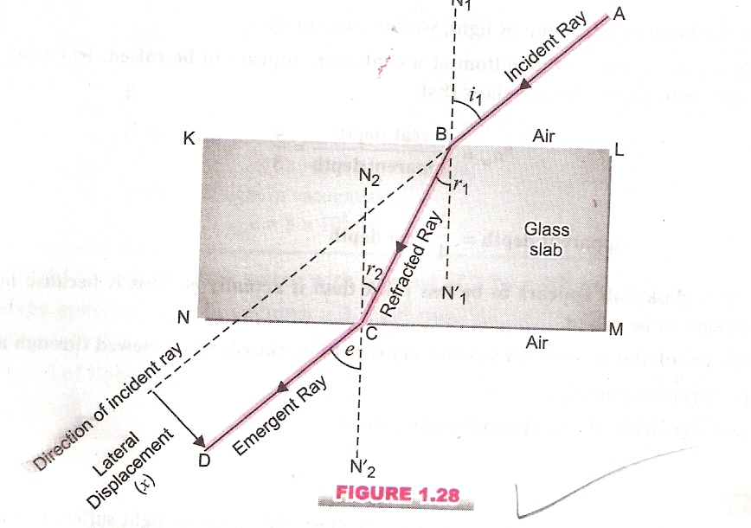
Thus light emerges from rectangular glass slab in a direction parallel to that it entered the glass slab.

a

Lateral displacement :- On passing through a rectangular slab, a ray of light suffers two refractions. The final emergent ray is parallel to that of incident ray but is shifted side ways from the direction of original incident ray. This shift is called lateral shift or displacement and is equal to the perpendicular distance between the incident ray and the emergent ray. The displacement of the emergent ray depends upon the thick ness of the glass slab.
Conditions of no refraction:
There are two conditions when no refraction of light takes place in a transparent medium.

(1) When light is incident normally on a boundary: A ray of light travelling in medium 1 falls along normal on xy, where xy is he boundary between medium 1 and medium 2.
Angle of incidence ∠i = 0^{O}
According to Snell’s law, sin_{i} ₌ µ₂
sin_{r} µ₁
or sinr ₌ µ₁
sini µ₂
sinr ₌ µ₁ sini (1)
µ₂
As ∠i is zero,
∴ in equation (1) sinr = µ₁ sin0
µ₂
or sinr = 0 -------(because sin0 = 0) [∴ sin nπ = 0]
Therefore,∠r = 0⁰ where ∠r is the angle of refraction.
As the angle of refraction in medium 2 is zero, i.e. the ray of light passes undevaited through medium 2, and passes along OB after refraction as shown in figure (which is in line with incident ray AO). Thus no refraction occurs when light is incident normally on a boundary of two media.

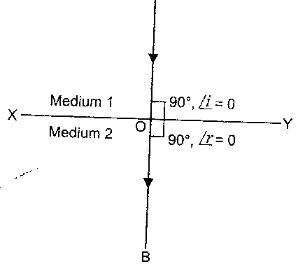
A

(2) When the refractive indices of two media are equal: A ray of light AO traveling in medium 1 is allowed to pass through medium 2 having refractive index same as that of medium 1. As there here is no change in the speed of light when it goes from medium 1 to medium 2, hence the light passes undevaited.
If n₁ and n₂ be the refractive indices of medium 1 and medium 2, then according to Snell’s law
sini ₌ µ₂ (1)
sinr µ₁
as µ₁ = µ₂ (2)
From equation (1) and (2) we have,
sini ₌ 1 ₌ 1
sinr 1
or sini = sinr
or ∠i = ∠r
as the angle of incidence is equal to the angle of refraction, the ray of light passes undeviated through medium 2 i.e. no bending of light takes place when it enters into medium 2.
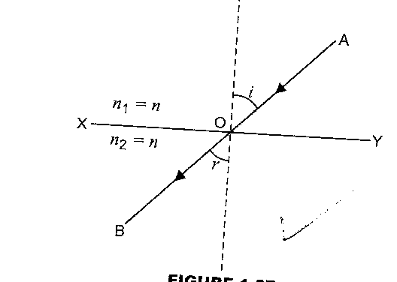
Hence, no refraction takes place at the boundary that separates two media of equal refractive indices.
µ₁ = n
µ₂ = n

Lens: A lens is a piece of transparent material having some magnifying power.
Spherical lenses: A spherical lens is a Piece of transparent material having either one or both surfaces curved. In case of a lens, an image is formed by refraction at the both surfaces. Spherical lenses are of two types:
(i) Convex or converging lens (ii) Concave or diverging lens
(i) Convex or converging lens: The lens which is thick at the centre and thin near edges is known as convex lens. It is also called as converging lens because it converges the rays of light falling on it.
All the convex lenses are convergent lenses but all convergent lenses are not convex.
(ii) Concave or diverging lens: The lens which is thin at the centre and thick near the edges is known as concave lens. It is also called as diverging lens, because it diverges the rays of light falling on it.
All the concave lenses are divergent lenses but all divergent lenses are not concave.
Q):- Define the following terms:-
1) Aperture :- The aperture of a lens is the diameter of the circular edge of the lens, In given figure AB represents aperture of the lens.
2) Centre of Curvature :- A lens whether convex or concave has two spherical surfaces. Each of these surfaces form a part of a sphere. The centres of these spheres are called centres of curvature of the lens. They are represented by C₁ & C₂ in given figure (a) and C₁` and C₂` in figure (b)
3) Principal axis:- An imaginary straight line passing through the centres of curvature of the two surfaces of the lens is called principal axis of the lens.
In given figure, line C₁C₂ represents the principal axis of a convex lens and line C₁` C₂` represents the principal axis of a concave lens.
4) Optical Centre :- The centre point of a lens is known as its optical centre. It lies on principal axis of lens. The ray of light passing through optical centre of lens suffers no refraction. i.e. light rays pass undeviated through optical centre It is represented by .’C’.
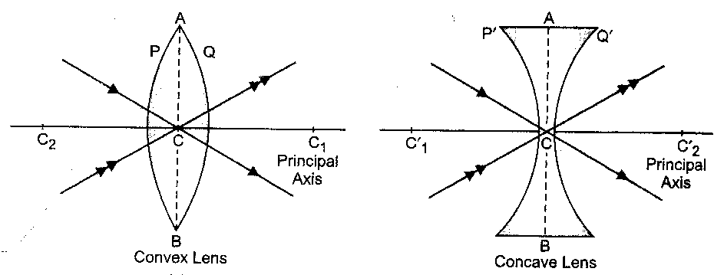

(a) (b)
Q):- Define the principal focus & focal length of a convex lens?
Ans:- A convex lens has two surfaces & hence it has two focal point or principal foci.
First principal focus of a convex lens is the position of point object on the principal axis of the lens, for which the image formed by the lens is at infinity. It is represented by F_{1.}
First focal length: The distance of first principal focus of the lens from optical centre ‘C’ of the lens is called first focal length of convex lens. In above figure, f₁ = CF₁ It is represented by f₁.
Second Principal Focus of a convex lens is the position of an image point on the principal axis of the lens, when the point object is situated at infinity. It is denoted by F₂ . It is a real point.
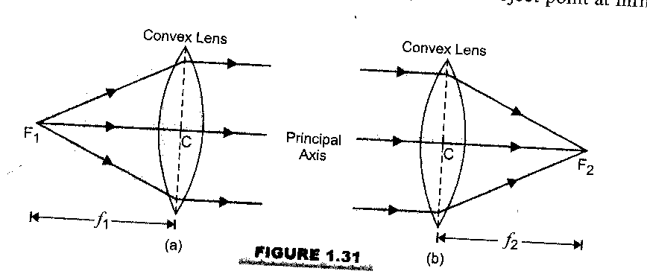
Second focal length The distance of 2nd principal focus of the lens from the optical centre “C” of the lens is called second focal length of convex lens. It is represented by f₂. Thus in given figure f₂ = CF₂.

Q):- Define principal focus & focal length of a concave lens?
Ans:- A concave lens has two surfaces & hence it has also two focal points or two principal foci
First principal focus of a concave lens is the virtual position of the point object on the principal axis of the lens, for which the image formed by concave lens is at infinity. It is represented by f₁.
First principal focal length of concave lens: The distance of first principal focus of the lens from optical centre ‘C’ of the lens is called first principal focal length of concave lens. It is represented by f_{1.} Thus in figure f₁ = CF₁
The Second principal focus of a concave lens is the position of the image point on the principal axis of lens, when the point object is situated at infinity. It is represented by F_{2.} It is virtual point.
Second Principal focal length of concave lens: The distance of second principal focus of the lens from the optical centre of the lens is called 2nd principal focal length of concave lens. It is represented by f₂. Thus in given figure f₂ = CF₂
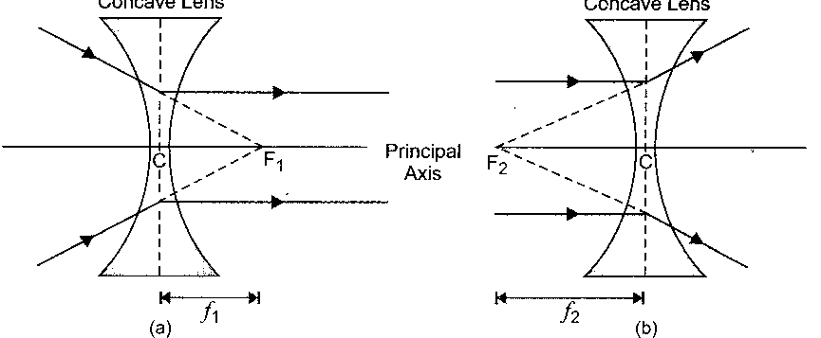

Q):- What are the rules used for obtaining image formed by convex lenses?
Ans:-When an object is placed in front of a convex lens, an image is formed, at that point where at least two refracted rays meet (or appear to meet).
Rule 1:- A ray of light which is parallel to the principal axis of a convex lens, passes through its (second) principal focus after refraction through the lens as shown in fig (a)
Rule 2:- A ray of light passing through the optical centre of a convex lens passes straight after refraction through the lens as shown in figure (b).
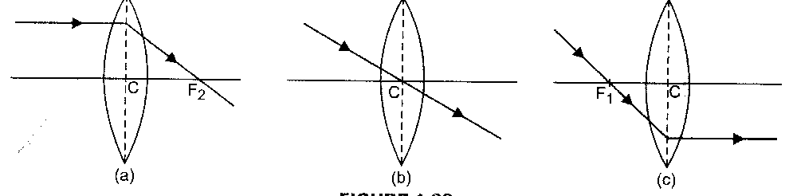
Rule 3 :- A ray of light passing through the (first) principal focus of a convex lens becomes parallel to its principal axis after refraction through the lens as shown in figure (c).

Q):- Discuss the image formation by convex lens with the help of ray diagram?
Ans:- The type of image formed by a convex lens depends on the positions of the object in front of lens. Following six cases arise..

Case 1:- When the object is placed at infinity.

Two parallel rays of light AC and AD are inclined to the principal axis of the lens. The ray AC passes undeviated through optical centre and ray AD converges on refraction through the convex lens. The two refracted rays actually meet at A~.

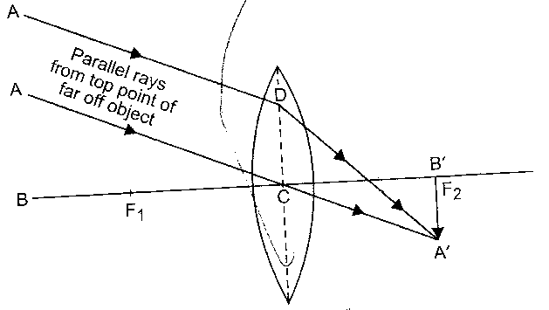
The image is formed at the second principal focus (F₂) of the convex lens. The image is real, inverted & highly diminished as shown in figure.

Case II:- When the object is placed beyond 2F₁:

A ray of light starting from A and incident on the lens along AD in a direction parallel to the principal axis of the lens, on refraction passes through second principal focus F₂ of the lens. Another ray of light starting from A and incident on the lens along AC, goes undeviated through the optical centre of the lens. The two refracted rays meet actually at A`.

The image formed is between F₂ & 2F₂. The image is real inverted & diminished as shown in figure
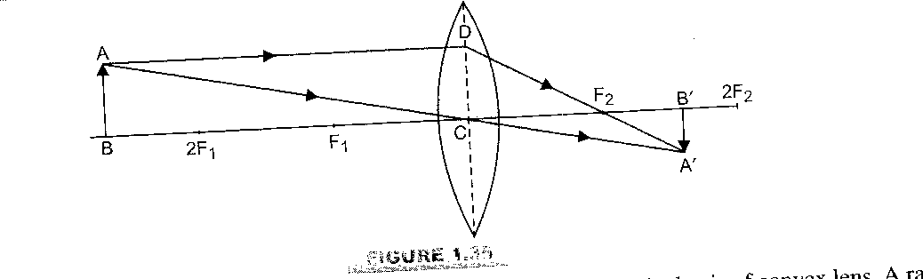

Case III:- When the object is placed at 2F₁ (F₁ is first principal focus):

A ray of light starting from A and incident on the lens along AD in a direction parallel to principal axis of the lens, on refraction, passes through second principal focus F₂ of the lens. Another ray of light starting from A and incident on the lens along AC, passes undeviated through the optical centre. The two refracted rays meet actually at A`.

The image is formed at 2F₂. The image is real, inverted & same in size as shown in figure.
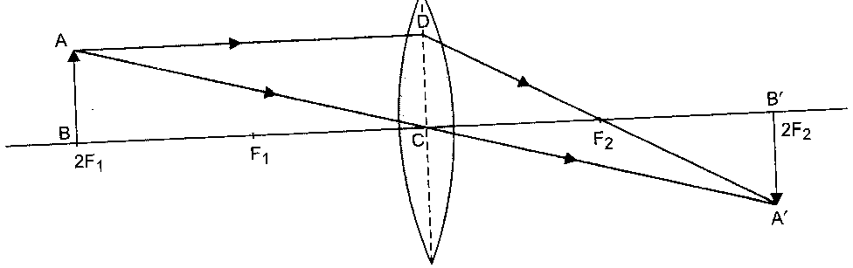

Case IV: When the object is placed between F₁ & 2F₁:

A ray of light starting from A and incident on the lens along AD in a direction parallel to the principal axis of the lens, on refraction, passes through second principal focus F₂ of the lens. Another ray of light, starting from A and incident on the lens along AC, passes undeviated through the optical centre C of the lens. The two refracted rays meet actually at a point A`.

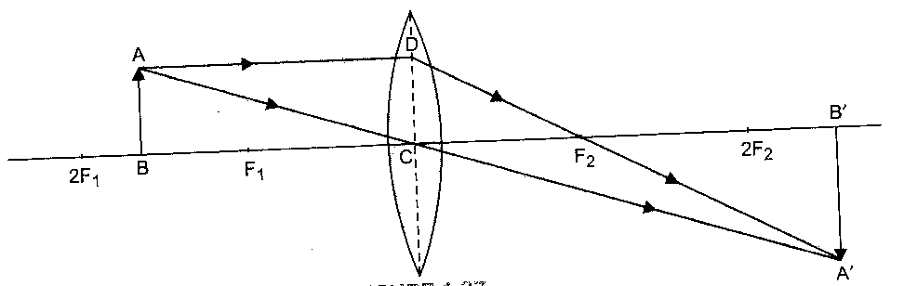
The image is formed beyond 2F₂ on the other side of convex lens. The image is real, inverted & enlarged as shown in figure.

Case V : When the object is placed at F₁.:

A ray of light starting from A and incident on the lens along AD in a direction parallel to the principal axis of the lens, on refraction, passes through second principal focus F₂ of the lens. Another ray of light, starting from A and incident on the lens along AC, passes undeviated through optical centre C of the lens. The two refracted rays emerge from the lens in a direction paralleled to each other, as shown in figure. Those rays would meet at very large distance from the lens, say at infinity.

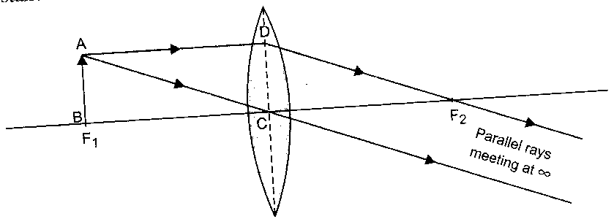
The image is formed at infinity. The image is real, inverted & highly magnified as shown in figure.

Case VI :- When the object is placed between F₁ & ‘C’:

A ray of light starting from A and incident on the lens along AD, in a direction parallel to the principal axis of the lens, on refraction, passes through second principal focus F₂ of the lens. Another ray of light starting from A and incident on the lens along AC, passes undeviated through optical centre C of the lens. The two refracted rays from the lens are diverging and would not meet on the right side of the lens. However, when we produce the two refracted rays in the backward direction, they appear to come from the point A`.

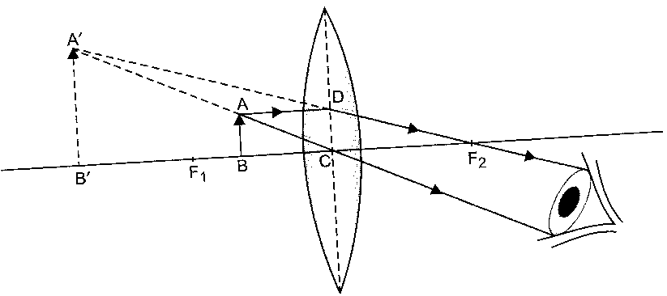
The image formed is beyond f₁ on the same side of the lens the image formed is virtual, erect & enlarged as shown in figure.

Formation of image by concave lens:
Q) What are the rules used for obtaining image formed by concave lens?
Ans) When an object is placed infront of a concave lens, an image is formed. The image is formed at that point where at least two refracted rays meet (or appear to meet).
Rule 1) A ray of light which is parallel to the principal axis of a concave lens, appears to be coming from its focus after refraction through the lens. as shown in fig (a)
Rule 2) A ray of light passing through the optical centre of a concave lens goes straight after passing through the lens. as shown in fig (b)
Rule3) A ray of light appearing to meet at the principal focus of a concave lens after refraction, will emerge parallel to the principal axis of the lens. This is shown in figure (C).
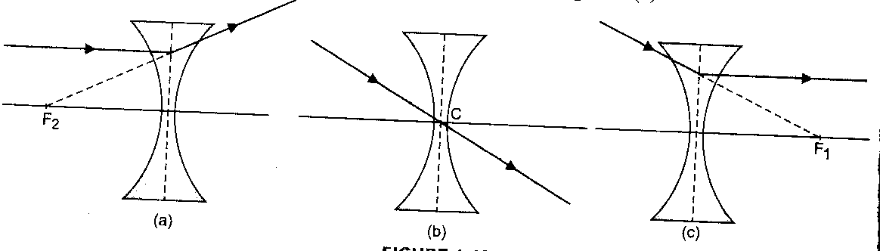

The image is formed at a point, where the two refracted rays appear to meet. For all positions of the object, the image formed by a concave lens is virtual, erect and diminished in size. The exact position and size of the image would depend upon the position of the object.
Two cases arise:
Case 1) When the object lies between optical centre and infinity:

A ray of light AD starting from the top point A of the object is falling on the concave lens in a direction parallel to principal axis of the lens. This ray diverges after refraction along DE and on producing back; it appears to come from second principal focus F₂ of the lens. Another ray of light AC starting from the same point A on the object, passes undeviated through the optical centre C, along ACG. The two refracted rays intersect at A`. Therefore, A` is virtual image of the point A on the object.

When an object is held anywhere between optical centre C of concave lens and infinity, the image formed is:
(i) Between optical centre C and second principal focus F₂; on the same side of the lens and the image is,
(ii) Virtual and erect and

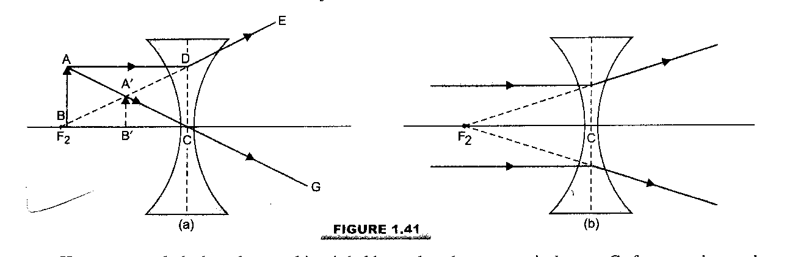
- Smaller in size than the object.

Fig. (a)
Case 2) When the object is at infinity:
When the object is at infinity point, image is formed at the second principal focus on the same side of the lens. This is shown in figure (b). The image is virtual, erect and highly diminished to almost point size.

fig (b)
Q):- What are the new cartesion sign conventions used for lenses?
Ans:- The new Cartesian sign conventions are given below:
1) All distances are measured from the optical centre of the lens.
2) The distances measured in the direction of incident light are taken as positive.
3) The distances measured in a direction opposite to incident light are taken as negative.
4) The distances measured upwards & perpendicular to the principal axis are taken as positive,
5) The distances measured downwards & perpendicular to the principal axis are taken as negative.
6) The principal axis of the lens is taken along x-axis and optical centre “C” of the lens is taken as
the origin.
7) The object is taken on the left side of the lens.
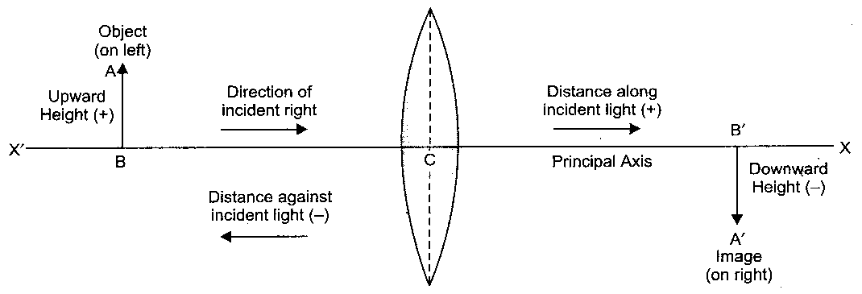

Q):- What is the lens formula?
Ans:- The relationship between image distances (v), Object distances (u) & focal length ‘f’ of a lens is known as lens formula & is written as:
1 1 1
– =
v u f
This lens formula applies to both types of spherical lenses, Convex lens as well as the concave lens. New sign conventions must be used while substituting normal values for v,u and f.
Q):-What do you understand by linear Magnification produced by lenses?
Ans:- The linear magnification produced by lenses is the ratio of the size of the image to the size of the object. It is represented by m.
Thus linear magnification = size of I mage
size of object
if “h₁” is the size of the object and “h₂” size of the image then, m = h₂ (1)
h₁
The linear magnification produced by a lens in terms of the image distance and object distance is equal to the ratio of image distance to the object distance.
Thus magnification ₌ image distance
object distance.
If “I” is the image distance and “O” is the object distance.
Then m ₌ I (2 )
O
From equation (1) and (2) we have
m ₌ I ₌ h₂
O h₁
A concave lens forms an image which is always smaller than the object . Therefore linear magnification of a concave lens is always less than one (1).
In case of a convex lens:
(i) When the size of an image is equal to the size of the object i.e. h₂=h₁. Therefore
m ₌ h₂ ₌ 1 ₌ _{1.} thus the magnification is equal to one (1)
h₁ 1
(ii) When the size of the image is greater than the size of the object i.e. h₂ is greater than
h₁ as m ₌ h₂ _{> 1}
h₁
then m is greater than one (1).Thus linear magnification is greater than one
(iii) when the image is smaller than object i.e. h₂ is less than h₁,
as m= h₂ , then “m” is less than one. Thus linear magnification is less than one
h₁
.Q):- Define Power of a lens?
Ans:- The power of a lens is defined as the ability of lens to converge the rays of light falling on it . A convex lens converges the rays of light falling on it, power of convex lens is said to be positive.
A concave lens diverges the rays of light falling on it . Therefore power of a concave lens is said to be negative.
The power of a lens depends on its focal length . Mathematically, the power of lens is given by reciprocal of focal length of the lens i.e,
Power of lens 1 i.e. 1
P =
P =
Focal Length of the lens(f) f
Where ‘f’ is in metres. However if f is in cm then power of a lens is expressed
as P = 100
f
Clearly, smaller the focal length of a lens, greater is its power & Vice-versa.
For a convex lens, ‘f’ is positive, therefore, ‘P’ is positive i.e., power of convex lens is positive.
For concave lens f is negative. So P is negative i.e. power of concave lens is negative.
The S.I unit of power of lens is dioptre, represented by ‘D”
When f= 1m, _{P =} 1 = 1 ₌1 dioptre.
f 1
Thus one dioptre is the power of a lens of focal length one metre.
The power of lens in diopters is called the number of lens e.g., a convex lens of focal length
50cm (f = 0.5m) has power ₌ 1 ₌ 2D
0.5m
Its number is said to be +2.
Similarly for a concave lens of focal length 10cm (f = _0.1m) has power
p= 1 = 10D
0.1
Its number is said to be 10.
Q):- What is the power of combination of lenses?
Ans:- When a number of thin lenses are placed in contact with one another, the power of combination is equal to the algebraic sum of the powers of individual lenses.
If P₁, P₂, P₃--------- are power of individual lenses placed in contact with one another, the power (P) of the Combination is P= P₁+P₂+ P₃-----------
It is important to note that individual powers have to be taken with proper sign, positive for a convex lens & negative for a concave lens.
Example: A convex lens of power +5D is placed in contact with a concave lens of power -2D.
The power of combination is P = P₁ + P₂ = 5D – 2D = 3D
Thus this combination would behave as a convex lens of power +3D.
Q) How to distinguish between a plane mirror, a concave mirror and a convex mirror without touching them?
Ans) We can distinguish between mirror by simply looking at the image of our face in three mirrors:
Plane mirror  A plane mirror will produce virtual and erect image of the same size as our face. So we will look our normal face in a plane mirror. | Concave mirror  A concave mirror will produce virtual, erect and magnified image of our face i.e. our face looks much bigger in a concave mirror. | Convex mirror  A convex mirror produced a virtual, erect but diminished image of our face i.e. our face looks much smaller in a convex mirror.
Textual questions
Q1. Define what do you understand by principle focus of a concave and convex mirror?
Ans. The principal focus of a concave mirror is a point on principal axis of the mirror, at which rays of light incident on the mirror in a direction parallel to the principal axis, actually meet (converge) after reflection from the mirror. It is represented by letter “F” In given figure parallel rays falling on concave mirror get reflected and meet at point F principal focus is real point lying always in front of concave mirror thus in case of concave mirror
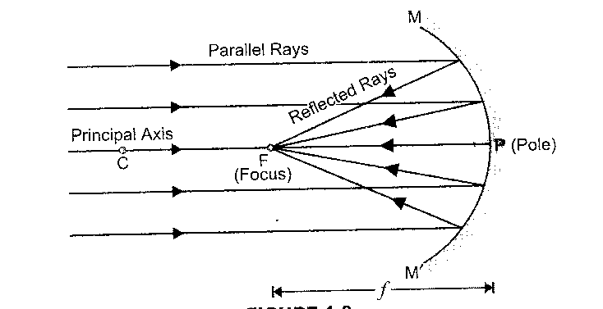

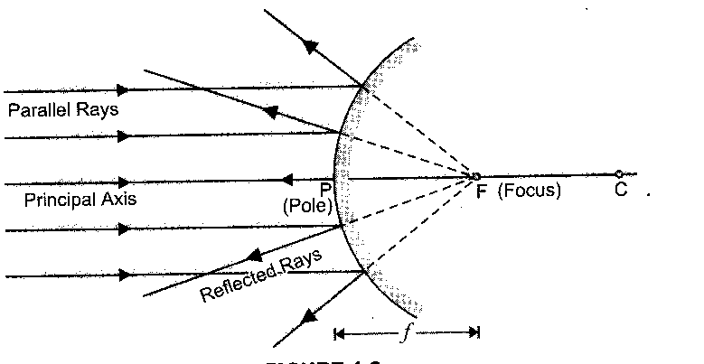
Principal focus of a convex mirror:- The principal focus of a convex mirror is a point on the principal axis of the mirror, from which rays of light incident on the mirror in a direction parallel to the principal axis, appear to diverge, after reflection from the mirror: It is represented by the letter F. In given figure parallel rays falling on convex mirror get reflected and diverge out. When the diverging reflected rays are produced back, they meet at F and appear to diverge from F. Thus F is the principal focus. Thus in case of convex mirror principal focus is a virtual point, which is always behind the mirror.

Q. 2 Name mirror that can give an erect and enlarged image of an object?
Ans. A concave mirror gives an erect and enlarged image of an object, when an object is held between the pole and principal focus of a mirror.
Q.3 Why do you prefer a convex mirror as a rear view mirror in vehicles?
Ans. A convex mirror is preferred as a rear view mirror in vehicles to see the traffic behind the rear side because;
- A convex mirror produces an erect image of the objects.
- A convex mirror produces the image of an object much smaller than the size of the object.
- Convex mirrors have a wider field of view as they are curved outwards. Therefore, convex mirrors enables the driver to view much larger area of the traffic behind him than would be possible in using plane mirror as a rear view mirror in vehicles
Q.4 A ray of light traveling in air en ters obliquely into water. Does the light ray bend towards the normal or away from the normal way?
Ans. When a ray of light travels from air into water obliquely it bends towards the normal. This is because water is optically denser than air on entering water, speed of light decreases and light bends towards normal.
Q.5 Your are given kerosene, tu rpentine and water. In which of these does the light travel fastest? Use the information given in the table?

Transparent media | Refractive Index | Transparent media | Refractive Index
Air | 1.0003 | Turpentine | 1.47
Ice | 1.31 | Diamond | 2.42
Water | 1.33 | Rock salt | 1.54
Alcohol | 1.36 | Benzene | 1.50
Kerosene Oil | 1.44
We know µ = ^{c}/_{v} where µ is refractive index, c velocity of light in vacuum and v
velocity of light in the medium.
From above equation it is clear that larger the value of refractive index of a medium smaller the speed of light in that medium and vice versa. i.e. light travels fastest in a medium whose refractive index is smallest. Of the above mentioned three liquids, water is having lowest refractive index, thus light travels fastest in it.

Q.6) Find out the medium having highest optical density. Also find the medium with lowest
optical density?
Ans) As we know that a medium is said to optically denser, whose refractive index is larger and a medium with smaller value of refractive index is said to be optically rarer. From above table it is clear that the medium with highest value of refractive index is diamond (2.42), thus diamond is the medium with highest optical density. Similarly the medium with lowest value refractive index is air (1.003) thus air is the medium with lowest optical density.
Q.6 Refractive index of diamond is 2.42 what does it mean?
Ans. Refractive index of diamond is (2.42). Therefore optical density of diamond is the largest. As µ = ^{C}/_{V} Therefore v = ^{C}/µ as µ is largest, v is smallest i.e velocity of light in diamond is minimum.
Q.7 Define one dioptre of power of a lens.?
Ans. One dioptre is the power of a lens of focal length/one metre.
Q.8 Which one of the following materials can not be used to make a lens? Water, Glass, Plastic, Clay?
Ans. Clay can not be used to make a lens, as it is not transparent.
Q.9 The image formed by a concave mirror is observed to be virtual, erect and larger than the object, where should be the position of an object?
Ans. For virtual, erect and larger image, the object must lie between the pole of the mirror and its focus.
Q.10 Where should an object be placed in front of a convex lens to get a real image of the size of the object?
Ans. The object is to be placed at twice the focal length of the lens.
Q.11 A spherical mirror and a thin spherical lens have each a focal length of –15cm. The mirror and lens are likely to be?
Ans. As per new Cartesian sign conventions are concerned, the focal length of a concave mirror and focal length of a concave lens, both are negative therefore both are concave.
Q.12. No matter how for you stand from a spherical mirror, your image appears erect. The mirror is likely to be (i) Plane (ii) Concave (iii) Convex (iv) either plane or convex.
Ans. The image is erect in a plane mirror and also in a convex mirror for all positions of the object. Therefore, the mirror is either plane or convex
Q.13 Which of the following lenses would you prefer to use while reading small letters found in a dictionary?
Ans. For reading small letters in a dictionary, we need to use a convex lens of smaller focal length.
Q.14 We wish to obtain an erect image of an object, using a concave mirror of focal length 15cm. what should be the range of distance of the object from the mirror? What is the nature of the image? Is the image larger or smaller than the object? Draw a ray diagram to show the image formation in this case?
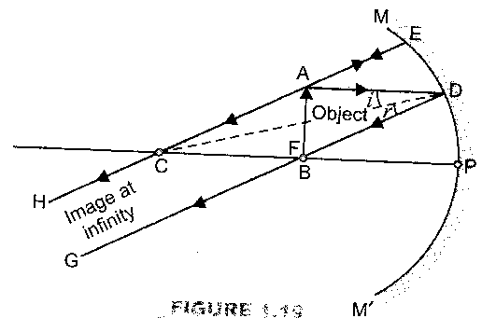
Ans. To obtain an erect image of an object in a concave mirror, the object is to be held between pole and principal focus of the mirror. Therefore, range of distance of the object from the mirror must be less than 15cm. The image will be erect and virtual. The size of image would be larger than the size of the object.

Q.15 Mirrors used in following situations:
(a) Head light of a car (b) Side rear view mirror of a vehicle
(c) Solar furnace
a. For Head light of a car we use a concave mirror to get a powerful beam of light. This is because when a lighted bulb is placed at the focus of a concave mirror, it produces a powerful beam of parallel light rays. This helps us to see things upto a considerable distance in the darkness of night.
b. For side rear view of a vehicle, we use a convex lens because its field of view is larger, and it forms virtual, erect and diminished images of objects behind.
c. For solar furnace concave mirror is used because light rays from sun after reflection from the mirror is concentrated at the focus of the mirror, producing heat in the solar furnace which is placed at the focus.

Q.16 One half a convex lens is covered with a black paper, will this lens produce a complete image of the object? Verify your answer experimentally? Explain your observations?
Ans. Yes, it will produce a complete image of the object, as shown in fig. this can be verified experimentally by observing the image of a distant object like tree on a screen, when half of the lens is covered with a black paper. However the intensity or brightness of image will reduce.
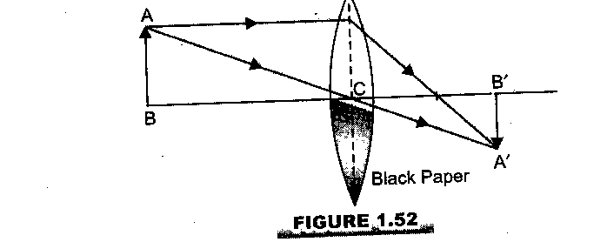

Q) Distinguish between convex and concave lens?
Ans) We can distinguish between a convex lens and a concave lens without touching them. Keep the two lenses side by side on one page of a book and look for image of writing on the page through the lens. If the writing appears enlarged, the lens is convex. If the writing appears shrunk (i.e. smaller) the lens is concave. This is because a convex lens produces an enlarged image of an object held between optical centre and principal focus and a concave lens produces a diminished image of an object held between centre and principal focus of the lens.
Characteristics of the image formed by a plane mirror.
- The image formed by a plane mirror is virtual.
- The image formed by a plane mirror is erect.
- The image formed by a plane mirror is of the same size as that that of an object.
- The image formed by a plane mirror is at the same distance behind the mirror as the object is in front of it.
- The image is literally inverted i.e. the right side of the object appears as the left side of the image and vice versa.
Distinguish between real and virtual image?
Ans) Real image | Virtual image
- Real images are those images which can be formed on a screen.  - Real image is inverted, diminished or enlarged.  - A real image is formed by the actual intersection of reflected or refracted rays.  - A concave mirror and a convex lens form a real image. When object is placed anywhere between infinity and focus. | - Virtual images are those images which can be seen only by looking into a mirror or a lens but can’t be received on a screen.  - Virtual image is always up right and diminished.  - A virtual image is formed by the apparent intersection of reflected or refracted light rays when their directions have been produced backwards.  - A convex mirror and a concave lens always form a virtual image.

Effects of refraction of light:
(1) A coin placed at the bottom of a container appears to be raised, when the container is
filled slowly with water. This can be explained on the basis of phenomenon of refraction.
The rays of light undergo refraction and bend away from the normal when they enter into water from air. Due to this refraction, a virtual image of the coin is formed nearer to the water surface. And since the virtual image of coin which we see is nearer to the water surface, so the coin appears to rise on adding water in the container i.e. the apparent depth of a container is less than the real depth of the container.
Thus, ªn_{w} ₌ real depth (1)
apparent depth
Where ªn_{w} is the refractive index of water with respect to air.
We know ªn_{w} = speed of light in air ₌ 3 x 10⁸m/s ₌ 4 (2)
speed of light in water 2.25 x 10⁸m/s 3
From equation (1) and (2) we have,
real depth ₌ speed of light in air ₌ 4
apparent depth speed of light in water 3
∴ Apparent depth = ¾ real depth
Similarly a tank of water appears less deep on account of refraction of light.
ªn_{w} = real depth of tank ₌ 4
apparent depth of tank 3
Apparent depth = ¾ real depth.
A stick (or pencil) partly immersed in water appears to be bent at the surface. This apparent bending of stick is due to the refraction of light when it passes from air into water.
Similarly, all the following effects are produced by refraction of light, when it passes from one medium to another.
(i) When a thick glass is placed over some printed matter, the letters appear raised
when viewed from the top.
(ii) A lemon kept in water in a glass tumbler appears to be bigger than its actual size
when viewed from the sides.
(iii) The stars appear to twinkle on a clear night.
Important points to remember
1. A concave mirror forms a real image most of the times.
2. Virtual image can be formed in both convex and concave mirror.
3. Image formed in a convex mirror is always smaller than object.
4. A ray passing through centre of curvature is normal to the mirror so angle of incidence= O⁰
5.A convex mirror and a concave mirror both can form a virtual image.
6.Dental surgeon’s use concave mirror for observing enlarged and erect images of teeth.
7) Incident ray: A ray of light which falls on a transparent surface is called the incident ray.
8) Reflected ray: A ray of light which is sent back by the mirror is called the reflected ray.
9) Refracted ray: A ray of light deviated from its original path on entering another medium is called refracted ray.
10 Silver metal is one of the best reflectors of light.
11) Ordinary mirrors are made by depositing a thin layer of silver metal on one side of a
plane glass sheet. The silver layer is then protected by a coat of red paint. The reflection of light in a plane mirror (or any other mirror) takes place at the silver surface in it.
12 The image formed by a plane mirror can be seen only by looking into the mirror.
13)We can not get image of our face on a screen held behind the mirror.
14) ENT specialists/doctors use a concave mirror as a “head mirror” to concentrate light on the body parts like eye, ear, nose and throat to be examined. Because a concave mirror concentrates all the parallel rays of light falling on it on to its focus.
15) A concave mirror can be used as a shaving mirror for gents and as a makeup mirror for ladies. Because the image formed by a concave mirror is virtual, erect and enlarged
The only condition is that the face should be close to the concave mirror so as to lie within the focus of the mirror.
16) Spherical mirrors can also be used as tricks mirrors to magnify one particular part and reduce the other part of an object.
17) We can see a full length image of a tall building in a small convex mirror. One such small convex mirror is fitted in a wall of Agra Fort to observe the full length of a tall tomb.
18) The plane containing the normal and the incident ray is called plane of incidence.
19) The plane containing the normal and the refracted ray is called plane of refraction.
20) A medium with the larger refractive index is optically denser medium than the other optical density of a medium determines the ability of the medium to reflect light. It is not the same as mass density of the medium. Mass density means mass per unit volume D=^{m}/_{v}.
21) The image formed by a convex lens may be real/virtual, inverted/erect, bigger/smaller/same size depending upon the position of the object. A concave lens forms a virtual, erect and smaller image, what ever be the position of the object..
22) A narrow beam of light is called pencil of light.
23) When a ray of light falls normally on a mirror, angle of incidence is zero i.e. ∠i = 0
24) A convex lens acts as a magnifying glass, when it forms a virtual, erect and magnified image of an object, for this, the object is to be placed between principal focus and optical centre of the lens.
25) Number of a lens represents power of lens. This number may be +ve or –ve.
26) When a parallel beam of light from a far off object like sun falls on a convex lens, a real, inverted, point size image of the sun is formed at the focus of the lens.
Thus that the image formed in a convex lens is always diminished and virtual. It can be taken on a screen.

